Name | Ahmed Naeem Bhuri
Student ID | 35446420
Studio Session | Thursday, 15 October 1:00 PM

Part A: URL of the Visualisation
https://abhu0013.github.io/Assignment-2/

Part B: Domain Description

Describe your domain chosen for DV II
The selected focus is the global cultural economy and competitive progression of the Pokémon Trading Card Game (TCG) from its inception in 1999 to 2023. This exploration goes beyond just the gameplay mechanics; it delves into how international participation has shaped the game's history and design. Instead of viewing the TCG merely as a pastime, we recognize it as a dynamic, global esports ecosystem. The narrative of the visualization connects physical geography, illustrating the game's growth from small local clubs in Japan to a vast international tournament scene with the mathematical transformation of the physical cards. It brings to light concepts such as systemic power creep, rarity economics, and printing biases in a way that enhances our understanding of the game's evolution.

Describe the Why and Who aspects of your DV II
- Who (Audience): The main audience for this content consists of competitive trading card game (TCG) players, esports historians, data-driven gamers, and local fans, with a special emphasis on Oceania as a leading destination for gaming. Additionally, it appeals to game designers who are keen on understanding how commercial card games strategically balance their mechanics to maintain player engagement over the long term.
- Why (Actions & Targets): Leveraging Munzner's framework, the primary aim of the dashboard is to weave a narrative surrounding the game's growth in both commerce and competition. On a more detailed level, users can pinpoint geographical hotspots for competitive play, helping to identify where the bulk of tournament participation occurs. Additionally, the dashboard facilitates comparisons of mechanical changes throughout various historical periods. It enables users to recognize trends like systemic power creep, such as the significant increase in Hit Points, and allows for an analysis of how publisher printing preferences impact the competitive standing of different elements and rarity tiers over time.
Describe the “What” aspect of your DV II
The "What" encompasses two primary external tabular datasets and one geospatial dataset, which have been heavily cleaned and transformed to extract narrative value:
- The Pokémon TCG Card Dataset (1999-2023):
  - https://www.kaggle.com/datasets/adampq/pokemon-tcg-all-cards-1999-2023/data
  - A comprehensive tabular dataset containing over 24 years of printing history. Key attributes include temporal data (exact release dates), quantitative variables (Hit Points, printing volume), and categorical/nominal metadata (supertypes, elemental types, rarity tiers, and expansion series).
- Tournament Attendance Dataset:
  - https://limitlesstcg.com/tournaments?time=all&type=worlds&format=all&region=all&show=100
  - A tabular dataset detailing major global competitive events. Key attributes include spatial data (latitude and longitude coordinates for host cities), quantitative data (player attendance figures), and categorical classifications (tournament tiers like Regional, International, and World Championship).
- Global TopoJSON Dataset (FIT3179 Repository):
  - https://github.com/FIT3179/Vega-Lite
  - Structural geographic boundary data (ne_110m_admin_0_countries.topojson) sourced from the unit repository, used to render the base world map geometries.
- Derived Data (Transformations):
  - Through Vega-Lite, raw data is abstracted into new derived attributes. This includes calculating national attendance shares, deriving statistical Kernel Density Estimates (KDE) for HP distributions, generating chronological window-ranked integers for the meta bump chart, and calculating normalized proportions for the area streamgraph.

Describe the “How” aspect of your DV II
The dashboard is designed with a clean and organized grid layout that presents information in a clear sequence. It includes 11 different data visualizations, featuring innovative custom chart types like Streamgraphs, Flow Maps, Bump Charts, Dumbbell Plots, KDE Density Areas, and Heatmaps. A well-defined color scheme enhances visual clarity: the Okabe-Ito palette ensures accessibility for colorblind users by distinguishing between different data types, while sequential gradients help to illustrate rarity. Specific colors such as Red, Blue, and Yellow are used to clearly differentiate tournament tiers.

To streamline user interaction, we’ve integrated interactive features directly into the charts. Instead of relying on external dropdown menus, you can easily highlight points connected to the legend or use interval selections for zooming and panning hence allowing for smooth and intuitive data exploration. Additionally, we've utilized internal data injection for editorial annotations which provide valuable context, all while maximizing the clarity of the visual data.
Chart-by-Chart Breakdown (Why & How):
1. Proportional Symbol Map (Historical Attendance at Major Events)
- Why: To pinpoint the specific metropolitan hubs driving competitive play and compare their raw tournament sizes alongside their prestigious tiers.
- How: A map utilises circle marks plotted via raw GPS coordinates. Size encodes quantitative attendance (capped at a maximum pixel area to prevent screen-swallowing), and colour encodes the nominal tournament tier. Reduced opacity is applied to blend overlapping regional clusters.
2. Choropleth Map (National Pokémon TCG Attendance Density)
- Why: To establish the global footprint of the game by showing the relative density of tournament attendance normalized by country.
- How: A geoshape map overlays data onto a TopoJSON basemap. A symmetric logarithmic (symlog) red colour scale is used to compress massive outliers (like the US), ensuring that smaller participating nations remain visibly distinct.
3. Flow Map (Cultural Import: The World Travels to Oceania)
- Why: To highlight the regional significance of Oceania by illustrating the convergence of elite international travel paths specifically to Melbourne.
- How: A custom equirectangular projection centers on the Pacific. Rule marks draw calculated flight paths from origin coordinates to hardcoded Melbourne coordinates, using low opacity to cleanly blend intersecting travel corridors.
4. Scatter Plot (Historical Power Creep: The Rise of HP)
- Why: To plot the raw trajectory of card health over time, highlighting how premium rarities consistently drive the maximum HP ceiling upward.
- How: Over 15,000 circle marks are plotted over time. A secondary aggregate layer draws a dashed line representing the annual maximum HP ceiling. The chart features an interval selection for mouse-wheel zooming/panning and legend-bound conditional opacity to highlight specific rarities.
5. Normalized Area Chart (Historical Distribution of Pokémon Types)
- Why: To reveal the proportional market share (printing bias) of different elements across years, independent of the total raw printing volume.
- How: Area marks are stacked using a normalize transform to force a 100% Y-axis scale. The Okabe-Ito colours are bound to a point selection parameter, allowing users to click the legend to isolate and highlight specific elemental bands while fading others.
6. Dumbbell Plot (The HP Gap: Minimum vs. Maximum Hit Points)
- Why: To emphasise the expanding mathematical disparity between the weakest and strongest cards within each historical era.
- How: A rule mark spans the quantitative gap between aggregated minimum and maximum HP values, capped by two distinct circle marks. The categorical Y-axis is custom-sorted by the earliest chronological release date rather than alphabetically.
7. Heatmap (Printing Bias: Type Distribution Across Card Series)
- Why: To expose dense, multidimensional patterns showing exactly which elemental types publishers favoured or neglected in specific historical expansions.
- How: A matrix of rectangle marks uses colour intensity (on a symlog scale) to encode printing volume. The canvas background fill was specifically set to match the lowest scale value, seamlessly blending "null" data cells (where no cards were printed) into the matrix.
8. Density Plot (HP Density Shift: Base vs Black & White vs Sword & Shield)
- Why: To statistically prove systemic power creep by showing how the actual shape (distribution) of HP has shifted rightward over 24 years.
- How: A Kernel Density Estimation (KDE) transform calculates probability curves. Areamarks render the overlapping curves, while a secondary, invisible thick line mark is layered on top to provide a flawless, bug-free tooltip hover target.
9. Bump Chart (The Competitive Meta: Top 6 Elements Ranked by Series)
- Why: To track the turbulent popularity and competitive rank of different elemental types through historical eras.
- How: A window transform dynamically calculates ranks within each series. Heavy monotone lines connect the chronological ranks. A massive ternary calculation block was built to clean and sanitise raw nested arrays into single categorical strings.
10. Box Plot (Statistical HP Spread: Lower Tier vs. Premium Rarities)
- Why: To summarise how HP distributions heavily favor artificially scarce premium cards over common ones.
- How: Box plots use a custom min-max extent to show the true floor and ceiling of engineered card stats, intentionally hiding outlier dots to maintain a clean visual. A sequential blue colour scheme reinforces the tier hierarchy, completely eliminating the need for a redundant colour legend.
11. Streamgraph (The Deck Ecosystem: Pokémon, Trainers, and Energy)
- Why: To provide a high-level, organic summary of the overall volume and fundamental card composition of the game across its entire lifespan.
- How: An area chart utilises monotone interpolation and stack: center properties to push quantitative volume outward from a hidden zero-axis, creating flowing, fluid bands. Data is filtered to remove null supertypes prior to rendering.

Part C: Sketch
A URL to a PDF document with an image of your sketch on your GitHub account.
Tip: Test your URL in incognito mode to ensure it is a working URL
https://github.com/abhu0013/Assignment-2/blob/52f9528eb239e9049cb8de083f39d2b74e3a86c5/%5BSKETCH%5D%2035446420_AhmedNaeemBhuri.pdf

Paste a screenshot of your sketch for your DV II.
Note: Use the entire page here for the screenshot and ensure that it is clearly legible and visible

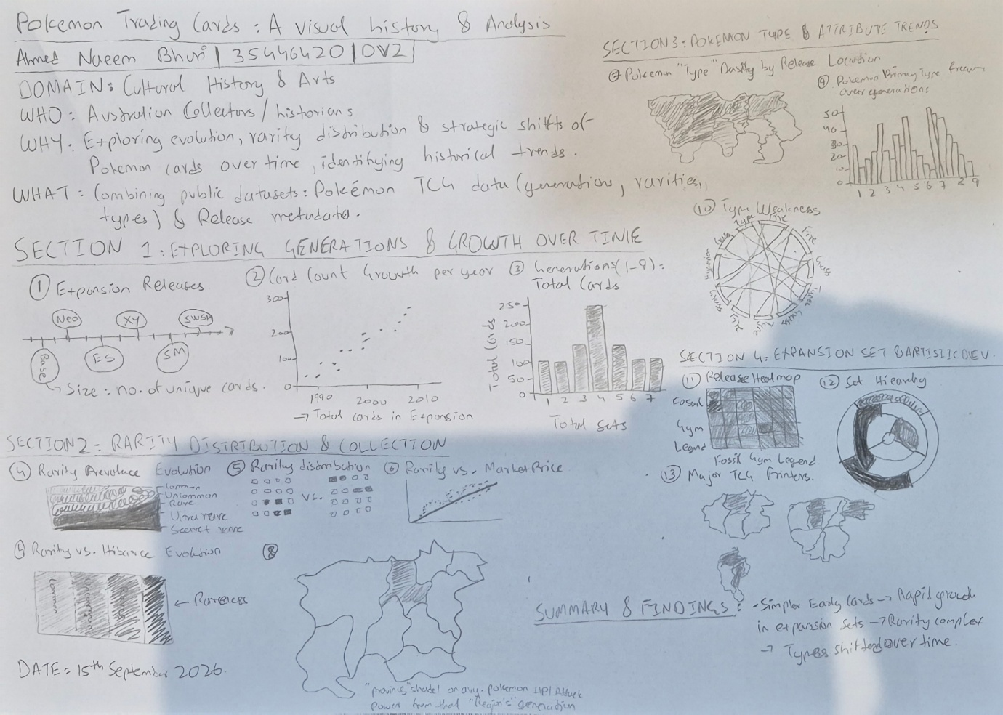

Part D: Full-size screenshot of your DV II
Paste a full-size screenshot of your DV II assignment from the URL here

